T H E U N I V E R S I T Y O F B R I T I S H C O L U M B I A UBC Wellness Centre

TIME MANAGEMENT:
It’s about time!

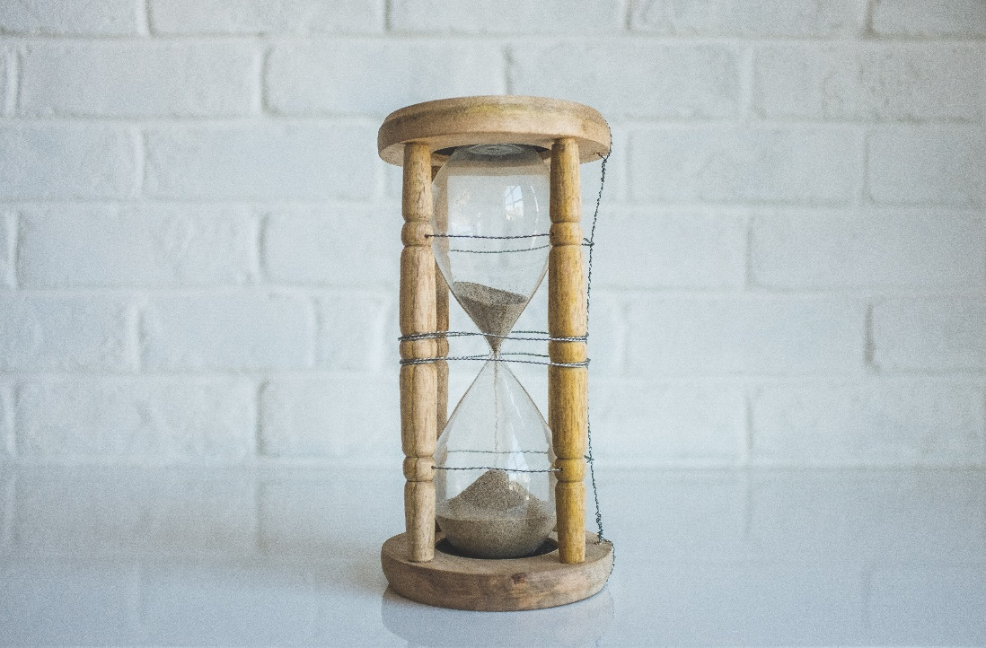

students.ubc.ca

EXERCISE #1: WHERE DOES THE TIME GO?

PERSONAL TIME SURVEY

Number of hours of sleep each night | ________ X 7 = _______
Number of hours on personal care (e.g. showering, brushing teeth, doing your hair, putting on makeup, etc.) | ________ X 7 = _______
Number of hours for meals/snacks per day (include preparation, shopping & buying time) | ________ X 7 = _______
Number of hours each week spent on physical activity (e.g. going for walks, yoga class, etc.) | ____________________
Total travel time weekdays (commuting)  Other travel time | ________ X 5 = _______  ____________________
Number of hours spent connecting with family, friends, or partner(s) (e.g. socializing, obligations, etc.) | ____________________
Number of hours per week for school commitments (e.g. classes, group meetings, labs, seminars, tutorials, etc.) | ____________________
Number of hours spent studying each week (e.g. reading, writing, discussions, study groups, etc.) | _____________________
Number of hours per day for chores and errands | ________ X 7 = _______
Number of hours per week spent to recharge on your own (e.g. personal time, self care, etc.) | _____________________
Number of hours of work per week | ___________________
Number of hours spent budgeting or reviewing finances per week | ___________________
Number of hours each week spent practicing your faith and/or fulfilling spiritual needs | ___________________
Number of hours each week spent on volunteering | ___________________
Number of hours each week spent on hobbies and having fun | ___________________
OTHER:  ________________________________________  ________________________________________  ________________________________________  ________________________________________ | ____________________  ____________________  ____________________  ____________________
Now add up the totals: | ____________________
Subtract the above number from 168
The amount of time you have left over each week | 168- _______= _______

- If you have time left over, ie. a positive number, how do you want to utilize this time?

- If you have a negative number, what can you adapt to give yourself more time in the areas you may want?

- How will this exercise help you to better manage your time?

EXERCISE #2: YOUR ENERGY CYCLE

Fill in the beginning and ending of your day on the chart. Draw a line through the day to reflect your typical energy cycle.

100%
0%

_______AM _______Noon ______PM

Try planning your activities according to your personal energy cycle.
Take advantage of the time when you are “at your best”!
Your peak energy time is a better time to do deeper, more in depth work.

- How could you better utilize your period of peak energy?

- How can this exercise help you to better manage your time?

EXERCISE #3: SETTING PRIORITIES

Your priorities are flexible and change over time. Revise your list every week.

To Do List:

 | Urgent (Due soon) | Not Urgent (Not due soon)
Important
Not
Important

EXERCISE #3: Procrastination Excuses

We may find ways to procrastinate on tasks which impacts ability to manage time effectively. Identify which thoughts you have that get in the way of following through on tasks.

The Truth | Unhelpful Conclusion | Helpful Conclusion
I am really tired | I am better off doing it after I have rested | But I can still make a small start right now
I will miss out on the fun happening now | I can always wait until nothing much is happening | But if I get some of it done, I can reward myself with fun later
I don’t have everything I need | I will wait until I do | But I can still try to make a start of some bits of the task
I have plenty of time | So I don’t have to start now | But better to get on top of it now than leave it to the last minute
I have other things to do | I will do it once those things are finished | But they are not more important and can be done after this

Challenge your conclusions:

- Is it really true that I will be better off in the long run delaying this task or goal?
- If I do make some start on the task or goal right now:
  - What might happen? How might I feel?
- Test the unhelpful conclusion:
  - Rate “the truth” (0-10), and then spend 5-10 minutes doing the task.
  - Following the task re-rate “the truth” and examine what you were able to achieve in the short period of time.

Encourage rather than criticize:

- Criticism compromises motivation
- Turn self-criticism into motivational self-talk.
  - Speak to yourself as you would to a friend who was in the same situation.

FURTHER INFORMATION
On Campus Resources

- Visit the UBC Learning Commons website at learningcommons.ubc.ca for access to peer tutoring (in-person and online), interactive workshops, study groups, peer assistance, and a wealth of other learning and research resources.

- Visit Student Services at students.ubc.ca/health-wellness for additional time management, stress management, and wellbeing resources.

REFERENCES

Academic Support Centre, Rochester Institute of Technology, Retrieved from http://www.rit.edu/~w-asc/documents/personaltimesurvey_dh_10_20_14.pdf

McRae, B. 1988. Practical Time Management. North Vancouver, BC: Self-Counsel Press.

University of Guelph. No date. “Learning Time,” The Learning Commons.
http://www.learningcommons.uoguelph.ca/investing_in_excellence/time_mana gement.html

York University. 2002. Time Management for University Students. Counselling and Development Centre. http://lss.info.yorku.ca/resources/university-timemanagement/

Queens University Time Management Handout
http://sass.queensu.ca/learningstrategies/wp-content/uploads/sites/2/2013/09/Managing-yourtime-at-university-graduate.pdf

University of Toronto Graduate Student Time Management Strategies: http://www.studentlife.utoronto.ca/Student-Resources/Gradlife/TimemanagementGrads.htm

Adapted from: Academic Support Centre, Rochester Institute of Technology, Retrieved from http://www.rit.edu/~w-asc/documents/personaltimesurvey_dh_10_20_14.pdf

